Some of the common Micro service design patters are:
1- Aggregator Pattern: In this pattern we breakdown large complex application using multiple service and then it get combined there result using on micro service. Below image is a

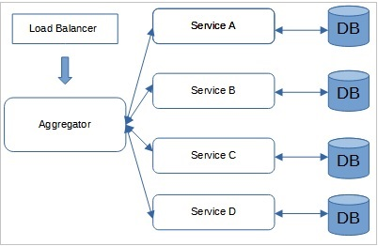

2- API Gateway: API gateway provide some answer for some question when an application get broken down to smaller micro services.
a) How to call multiple micro services abstracting producer information.
b) on different channel like desktop, mobile, tables. Apps need different data to responds for the
same back end service, as the UI might be different.
c) different consumers might need different format of the responses from reusable micro
services.

An API gateway is the single point of entry for micro service call. It can work as a proxy service to rout a request to the concerned micro service. It can also convert the protocol request to another protocol like AMQP to HTTP and vice versa so that producer and consumer can handle it. It can also use to implement authentication and authorization responsibility of the micro service.

3) Asynchronous Messaging:
4) Database per service micro service:
5) Circuit Breaking pattern: It is used to implement fault tolerant in micro service architecture. When a service is down then a fallback method is used to response to user and work as proxy service till original service get up successfully. There is some threshold that implement using this service. Netflix Hystrix is a popular circuit breaker pattern implementation pattern.
6) Decomposition -
Decomposition by business capability
Decomposition by subdomain
7) Command Query Responsibility segregation (CQRS): this patter is used to read and write data from and to database through two setup micro services.
8) Chained of responsibility:
9) Strangler Patter: It is uses to break Monolithic service to micro service. It derives its name from the way a vine slowly strangles a tree, gradually replacing its growth. Similarly, the strangler patter involves replacing parts of monolithic application with micro services over time.
10) Saga Pattern: This is used to perform ACID transaction in database per micro service. It uses event sourcing mechanism. When local transaction is done, it return an event message and it stores in saga executer service and when all transaction is completed then all event executed and perform final operation. Two way implements saga: Choreography: and Orchestration. Axon is popular library that is used implement Orchestration based Saga pattern.
11) Observability Pattern: it is used implement centralized logging in micro service. PCF has loggreator which collect logs from each component router, controller etc.
12) Service Discover Pattern: this pattern is used when IP addresses are dynamically allocated to service instances. Every time address changes, a consumer service can break and need manual changes. There are two kind of service discovery, client side and server side. Client side discover like netflix eureka and server side is AWS ALB.

